April 14, 2020

**DIVISIONMEMORANDUM**

**No. 107 S. 2020**

**ONLINE SURVEY ON INTERNET ACCESSIBILITY OF TEACHING AND NON -TEACHING PERSONNEL**

To: Assistant Schools Division Superintendent

Chief, Curriculum Implementation Division

Chief, School Governance Operations Division

All Heads of Public Elementary and Secondary Schools

1. This is to announce the accomplishment of Online Survey on Internet Accessibility of teaching and non-teaching personnel from April 20-24, 2020, in preparation for the Online Learning and Development Programs in the Schools Division of Angeles City.

.

2. The accomplishment of the Online Survey aims to:

2.1 gather data on the internet accessibility of teaching and non -teaching personnel;

2.2 identify the readiness of the teaching and non -teaching personnel on Online Learning and

2.3 strengthen online learning and development programs in partnership with the telecom providers.

3. All teaching and non-teaching personnel are required to accomplish the online survey tool using the links on or before April 24, 2020.

1.Teaching Personnel – <http://deped.in/TPIA>

2.Non- Teaching Personnel – <http://deped.in/NTPIA2020>

4. Immediate and wide dissemination of the contents of this Memorandum is earnestly desired.



**MA. IRELYN P. TAMAYO PhD, CESE**

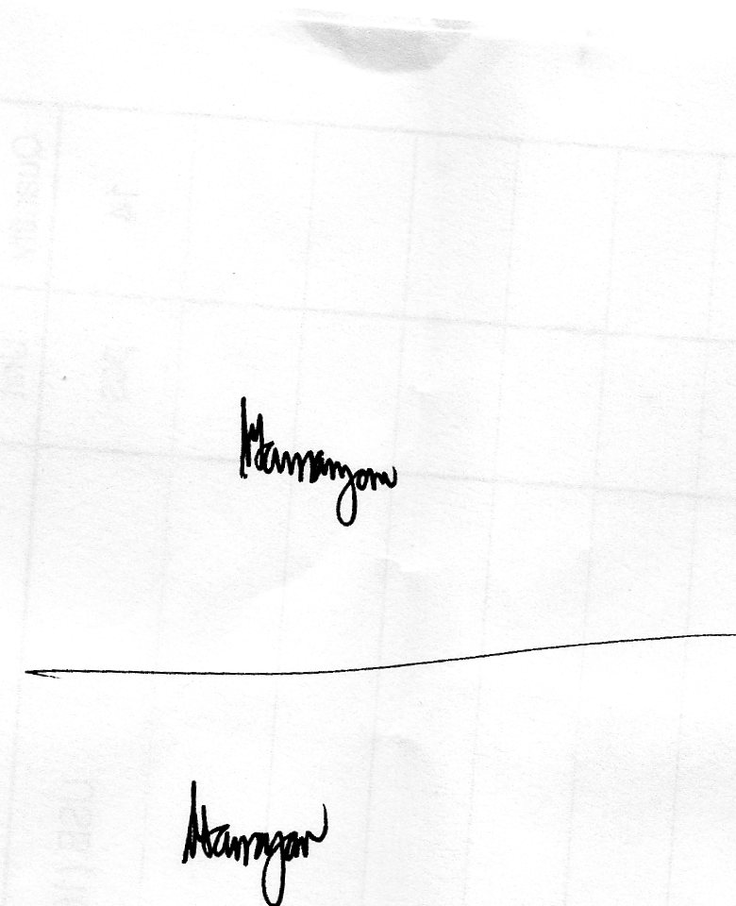 Assistant Schools Division Superintendent

Officer -in- Charge

Office of the Schools Division Superintendent